In a time of trial, especially for them, Kentucky newspapers come through for their readers
By Al Cross
Director and professor, Institute for Rural Journalism and Community Issues, University of Kentucky
In December, as the first coronavirus vaccines were being approved, the Commonwealth of Kentucky bought advertising in most Kentucky newspapers to get Kentuckians ready for the vaccination process. The $281,184 expense was a modest one, among billions of dollars in federal relief money that came to the state, but it was a timely boon for the newspapers. They were suffering from the double whammy of social-media competition followed by a pandemic that eroded even more of their ad revenue.
That ad order was also a recognition: that newspapers are still a good way to reach a large number of people with a broadly important message. And it could also be seen as a reward: for the newspapers’ performance in the pandemic. In perhaps the most challenging year for newspapers in their history, the community papers of Kentucky came through for Kentuckians.
They published special editions devoted to the pandemic. They told the stories of people affected and anguished by it. They published tributes to front-line local heroes. They served as trusted sources of information about a subject that became scientifically confusing and politically contentious. They helped readers separate fact from fiction, and they held public officials accountable.
Despite their financial squeeze, the newspapers took down paywalls, gave discounts to seniors and businesses, and kept sending papers to people who couldn’t pay their subscription bill, said Jeff Jobe, outgoing president of the Kentucky Press Association and publisher of seven weeklies in Southern Kentucky. His papers also made their body type larger to help seniors spending more time at home.
Soon after Gov. Andy Beshear ordered mask wearing in public enclosed spaces, Kentucky’s oldest paper signified the order.
This report is based on responses to a request for comments and documentation from KPA members, a random examination of Kentucky newspapers at the University of Kentucky library, and continuing research of the Institute for Rural Journalism and Community Issues.
The challenge
The pandemic has been a tough experience, said Alan Gibson, publisher and co-owner of the Clinton County News in Albany: “We have never gone through anything like this. With so many of our local businesses closing, either temporarily or permanently, our advertising base has dropped drastically. If they aren’t open for business, they have to need to advertise what they are offering for sale. I’ve said many times through this pandemic that I have more to report and more to write about now than ever before, and fewer pages to put it in that ever.”
Even before Clinton became one of the counties with the highest infection rates, Gibson made a “COVID-19” box a standard feature of his front page, and published transcripts of weekly news-media briefings by the Lake Cumberland District Health Department, dropping the gatekeeper role and letting readers see exactly how officials responded to questions.
That was often more revealing than Gov. Andy Beshear’s near-daily press conferences. On Oct. 21, officials said, “The lockdown was abandoned, not because it wasn’t good at controlling the spread of disease, but because society couldn’t live with that level of restrictions. . . . We would recommend that, since there is no way the health department can possibly police every business and every citizen, that everyone not patronize businesses that do not follow the mask mandate.”
To be sure, the performance of Kentucky newspapers was as varied as the papers themselves – from independent rural weeklies that struggled to print even four pages, to a few chain-owned papers that out-of-state corporations closed, to many more editors and publishers who took on the pandemic as the biggest story of their lives.
Some saw it as a chance to prove the worth of their work at a time of existential challenge. Russ Cassady, regional editor of Pikeville-based Appalachian Newspapers, said the attitude of his staff has been, “If we can work through this, we can keep newspapers going through at least a few more generations.”
Cassady said in an email, “Early on in the pandemic, we decided . . . that we needed to be at the forefront of coverage on this issue, particularly in terms of local response and impact.”
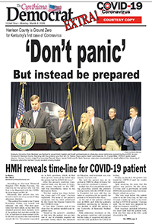
Special editions
That was the attitude Cynthiana Democrat Editor Becky Barnes had when Kentucky’s first case of the virus was reported in a person from her home Harrison County. She rode with the county judge-executive and the mayor of Cynthiana to Frankfort for a press conference with Beshear, and before they got back they had decided that the newspaper would publish a pandemic extra two days later, and the city and county would pay for it.
"Not everyone, especially in a rural county like Harrison County, has internet connection; not everybody is on Facebook; not everybody listens to the local radio," and some watch TV stations based in Cincinnati, not Lexington, Mayor James Smith said. "Some people in the county didn't even know we had a case in the county."
The Carlisle Mercury did a sample-copy edition for adjoining Nicholas County, and The Woodford Sun made one of its regularly scheduled editions a pandemic edition, paid for by the county, Versailles and Midway with relief funds.
Newspapers can reach everyone in their home counties quickly because postal regulations allow them mail up to 10 percent of their annual circulation in their home county to non-subscribers at subscriber rates.
Sometimes, even a regular edition looked like a pandemic edition. On Nov. 10, the front-page headlines in the Lewis County Herald were “Voters turn out for pandemic election,” “Lewis at 386 cases of Covid-19, 76 active,” “Covid restricts courthouse access,” “Lewis in red zone for second week,” and “Schools remain on virtual learning for now.”
Digital expansion
Some newspapers became more than newspapers, expanding their digital platforms and making their coverage 24/7, doing Facebook Live and YouTube interviews, and not just with local officials.
The long-digital Crittenden Press in Marion interviewed “local restaurant operators, beauticians, financial professionals and small business owners who were either impacted by closures or had information relevant to the situation,” said Allison Mick-Evans, co-owner of the weekly, which has a Facebook page and a YouTube channel, and uses Twitter and SnapChat to send out quick updates.
“We have also maintained our own database of all COVID-19 cases including their age, gender, disposition and outcome,” Mick-Evans added. “From that data source we are able to show weekly and monthly trends.” Several other papers do likewise.
Mick-Evans summed up the work of the paper’s staff of three: “As bad as the Covid-19 pandemic has been on families and communities. it has presented a unique opportunity for newspapers to be their best. . . . It has been an honor.”
Accountability journalism
Health departments and their boards, normally backwaters of local news coverage, became steady front-page news in the pandemic. Kentucky newspapers did news and feature stories about public-health workers and how they were overwhelmed, and also held health officials accountable.
Lexington Herald-Leader reporter Dan Desrochers, doing double duty with data and graphics, exposed shortcomings in the state's tracking system.
When the Lincoln Trail District Health Department said Nov. 30 that it would stop updating its local dashboard, and told local news media to use the state’s website, “We pushed back,” said Forrest Berkshire, editor of The Kentucky Standard in Bardstown.
“Some of the state’s info was either way behind (deaths) or did not even provide some of the details we had been using to cover this pandemic,” Berkshire said in an email. “The health department agreed to start emailing us the current info that they had so we could use it for reporting.”
Berkshire added, “I think sometimes the public does not realize how much work just collecting the information is for the news that we put out. The simple fact is, there is information that would not be put out publicly unless we were there pushing. Newspapers lead the way in that effort, from the local to the international level.
“This might be overstating it, but I often see small newspapers’ relationship to the broader, national-level news ecosystem almost like plankton is to the ocean's ecosystem. It’s small and rarely noticed by beachgoers and fishermen. But without it, the whole system would collapse and there would be no whale watching or sport fishing (full disclosure: I never took an ecology class in college).”
Deeper reporting
The virus affected almost every aspect of life in Kentucky, making almost every story a pandemic story and adding new angles to continuing stories.
The Todd County Standard, which has focused on the county’s shortage of broadband, did a story headlined “Connecting in Covid: Todd County continues struggle to get decent internet; everyone suffers,” especially children who have to learn online.
Many papers did stories about the struggles of students, parents and teachers, and more broadly, families and children. The Herald-Leader’s Linda Blackford moderated a “Learning Curve” live, online event about education during the pandemic, with Beshear, the state school board chair and higher-education officials.
The Hazard Herald, part of Appalachian Newspapers, reported that the local foster-care center expected an increase of foster children following the pandemic. The Bourbon County Citizen was one of the first to report an increase in drug overdoses in the pandemic.
Church is an important part of life for Kentuckians, and newspapers reported how they were dealing with the pandemic.
“We looked at how local ministers were getting creative to reach their congregations,” said Corbin News Journal Editor Mark White. “Some held services virtually through platforms like Zoom and Facebook Live. Others started holding drive-thru church, as it became known. People would drive to church on Sunday morning, park in the parking lot, and ministers would preach to audiences either via from a stage outside and a loud speaker, or through the use of a short range FM radio transmitter.”
In Bourbon County, Citizen reporter Pat Conley used an epigram from Matthew 18:20, “Wherever two or three come together in my name, there I am with them,” and quoted from “Eleanor Rigby” by John Lennon and Paul McCartney: “Father McKenzie, writing the words to a sermon that no one will hear. No one comes near.” The first quote was from a priest: “It’s especially a sad time for Catholics, because the Eucharist (Holy Communion) is the central part of our worship.” The story explored many angles, including the pandemic’s effect on church finances.
Not all stories about churches were features. Some defied Beshear’s order against mass gatherings, and The State Journal in Frankfort reported on one that did – which prompted a warning from the Franklin County Health Department, after which the nondenominational church took its “spring faith rally” online.
Editorial leadership
At a time of stress for society, the economy and families, some newspapers exercised editorial leadership to help maintain a sense of community and shared purpose. One was the Mount Sterling Advocate, which confronted the problem of misinformation in a March 26 editorial headlined “Let’s help one another, remain united during this uncertain time”:
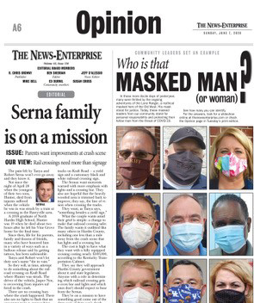
“Make sure you if you are relying on social media for information, it is from a trusted, reliable source — the governor’s office, CDC, health dept. and Mt. Sterling Advocate, for example. The Advocate is a small business as well, we also rely on your support! We are working diligently every week to bring you the latest updates and news regarding this and other important issues in our community. We encourage you to continue to buy the paper every week, advertise if your business is offering services, sign up for our e-edition, etc. As our governor continues to say, we are all in this together! We are all one team, we all have to work together, help one another and remain united. We will overcome this!”
On May 7, the paper gave Montgomery County a pat on the back: “We continue to be impressed locally with what residents, businesses, churches, individuals, etc., are doing to lift one another up. . . . Daily life has changed for all of us, and likely will continue to be different for some time. But we are staying positive here as best we can and helping to be there for another, and we are doing so in some fun, unique and creative ways. We hope this outpouring of support for one another continues! We are better as a team and better together! We are proud of our community and the level of outreach we’ve seen over the past several weeks during this uncertain time. We will get through this together!”
Some newspapers used creative presentations to send subtle messages about recommended public-health measures, some of which were unpopular. The News-Enterprise in Elizabethtown filled half its editorial page one day with portraits of local officials and other well-known people wearing masks. (Top half of page is shown.)
Editorials also kept local officials accountable. When the Anderson County Schools said the state’s directive that students “shall” wear masks at all times, unless seated at their desks and socially distanced, was open to interpretation, Anderson News Editor-Publisher Ben Carlson said the school district was “sending mixed signals when it should be sending absolutes.” Carlson said that wasn’t fair when “any local business taking similar liberties is subject to the full fury of government, up to and including being shut down.”
Creativity
As the pandemic wore on and pandemic fatigue set in, newspapers found new ways to make the topic fresh and keep readers focused on it.
The Adair County Community Voice ran a “Kill the Covid Contest,” a scavenger hunt for small, pandemic-related graphics hidden in one of its regular special sections on health and wellness, which is sample-copied to everyone in the county. Much of the section was devoted to stories about the pandemic, several from Kentucky Health News, which provides dozens of stories each month without charge. The front page regular section of the paper was also mainly about the pandemic; the lead story was “The unpredictability of Covid-19: Family shares experience after exposure to virus” and below that was a historical piece: “We’ve been through this before,” about the 1918 flu pandemic. Other newspapers did similar stories.
College newspapers had to adapt, too. The Bridge at Somerset Community College was one of several that went completely digital, since all instruction went remote in March. ”Articles we already had were updated and additional columns were included to give student perspective on the pandemic,” Co-Adviser Stuart Simpson said. “The PDF issue was emailed to everyone in the SCC community. Required to work remotely without advanced warning was tricky, and Jeff Harris, the other advisor, and I were proud of what the students produced.”
Community
While the pandemic put newspapers under duress, it also brought pleasure and pride in good work.
“The thing we have done that I am most proud of is for four weeks through part of April and May we ran two color pages a week honoring the essential workers in our county,” said Dana Brantley, editor of the Ohio County Times-News. “We asked people to submit photos (free of charge) of an essential worker they would like to honor. It was our way of honoring and thanking those whose work was/is so important to us during the time of a worldwide pandemic.”
But there has also been pain, and loss. One of the saddest stories about the pandemic must be the one written in early December by Dave Taylor of the Hancock Clarion in Hawesville. It began, “This was not the story I was supposed to be writing.” Rather than a story about how he and office manager Tomi Mathew “had both battled Covid-19 and won, each on our own stubborn ways, and each with such disparate symptoms,” it was a story about her death, at 63.
“Tomi's sudden death was a shock to us all here at the Clarion,” Publisher Donn Wimmer said in an email. “This has been tough on all of us. . . . I had some real good candidates for her job but we all decided we all could pitch in and do what Tomi did until the pandemic was contained and then consider hiring someone. Our business is holding up financially because we have produced two special sections in the last few months. That has helped. We received the first PPP and were hoping to get the PPP again but it looks like we will not qualify this time. I gathered my staff together to get them to go along with my new plan. I said lots of newspapers are downsizing but we are not! We are going to upsize and produce the best weekly newspaper in the area.”
Donn Wimmer, one of Kentucky’s longest-serving publishers, exemplifies the people who own and run Kentucky’s newspapers. They’re immersed in their communities, and their mission in life is to serve them. That has become more difficult than ever, because of technology and (temporarily) biology, but they persevere. As Alison Mick-Evans said, “It’s an honor.”
Dave Taylor’s observations for KPA, his story about Tomi Mathew and other examples of pandemic coverage follow.
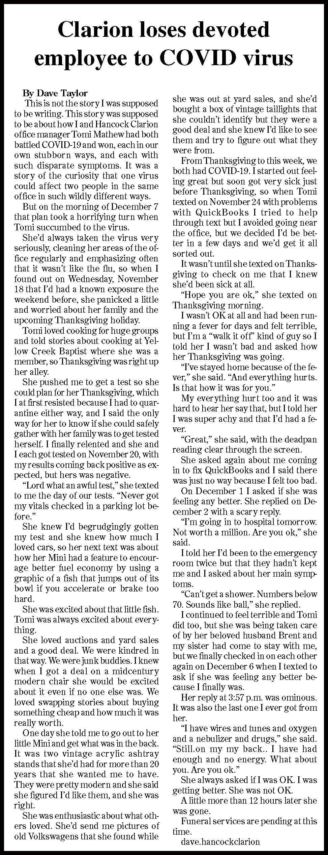
Pandemic performance makes public realize local newspapers are the best sources of information
By Dave Taylor
News Editor, Hancock Clarion
I was unaware at first that Tomi had tested positive for COVID-19 because I myself was quite sick with it, and by the time she texted to check on me and to tell me she had it too, she was also very sick.
But she wasn’t old, she wasn’t feeble, so I just knew she’d be OK in a couple of days and we’d share stories, and a little bond, because of our encounters with coronavirus.
When she died, it cast a pall over the office and left silence where there had been her loud “good mornin’” and confusion over where we order new printer toner and where we keep the new red pens.
She was the foundation for much of the operation of the office and with her gone we were left swaying in shifting winds.
In recent years we journalists have found ourselves competing not against other forms of news media but against posts on sites like Facebook by members of the public. This has hurt our status as the place to go to for information, but I believe that our actions during COVID-19 and otherwise have refocused the public’s perception that we are still the place to go for reliable, accurate information.
Beginning in March the Clarion offered free subscriptions to anyone who wanted one, in an effort to remove the barrier between the public and information.
We also removed the pay wall on our website for all stories related to COVID-19, and we continue those practices today.
When businesses hurt, newspapers hurt, so when coronavirus restrictions shuttered some businesses and fears over being in public sent other businesses’ customers to online retailers, our ad revenues suffered too.
But while our revenues have swooned, our reputation as an information source has improved. The public saw that posts on someone’s social media page were often wrong or exaggerated, but stories in our paper could be trusted.
Social media isn’t vetted; newspapers are. We have stated and established standards for ethics and accuracy. That, I believe, will be the saving grace of true journalism.
